**Progress Report**

**Group Member：**

**Zhiwei Zhang**

**Bingling Fu**

**Chi Zhang**

**Abstract**

Football is one of the most popular sports, and many people are watching it closely. Many of them are viewing the scores of their games online and are looking for as much information about their teams or leagues as possible. Most competitors only provide basic information and real-time scores. The goal of this project is to create an application where I can add interesting player statistics that may be interesting to these fans. Our Project shows basic information about different coach, matches, teams and players. It also shows previous and future matches, as well as the current rankings for each game. The additional information I've made is to create a next round of league tables that show how the league can change in the next round and how much each team can rise or fall in that round and consider the game to play. This report covers the reasons for the creation of the project, which is the main competitor and how it was developed. Give another comparison based on the given feedback. Errors are being discussed and further developments proposed.

**Introduction**

Before we enter the project, I want to explain the structure of different leagues first. In out project, I cover the English Premier League, Germany's first Bundesliga, Ligue 1 and Spain Serie A and Italy Serie A and other different matches. All teams in the league will play against each team's (N-1)*2 game twice, where N is the number of league teams. The first teachers in each country are working The first split team in each country competes for the first (championship), Champions League and Euro league seats and avoids downgrades. The second division is fighting for the first place (champion), advances and again avoids relegation. You can see the location assignment in the Table

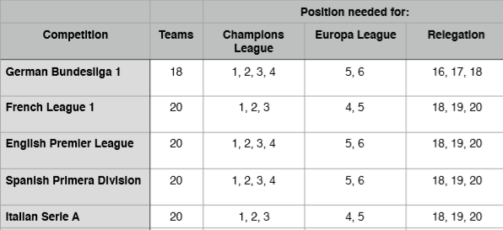

**Goal**

My initial goal was to create a database where people could view live scores, information about different leagues, teams, and even players. Since these statistics are very specific, my idea is that the project I create are primarily for personal use by me. If I expand enough and get enough interest, I can publish it for more people.

**ER Diagram**

The ER diagram include 9 entities, these entities are player, team, league, country, match, media, stadium, fans and coach. We use an Entity Relationship Diagram to model the database. Each Entity in our project has a unique identifier as primary key and relationships between them have one-one, many-one, and many-many.

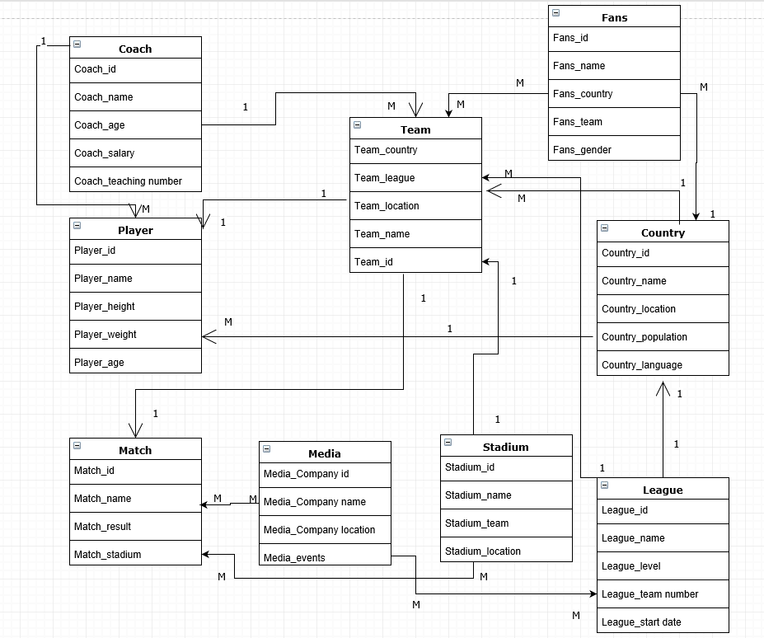

**Data Analysis**

Use Case 1:

We find

Join table match and country to find which name of the country is start from “p”

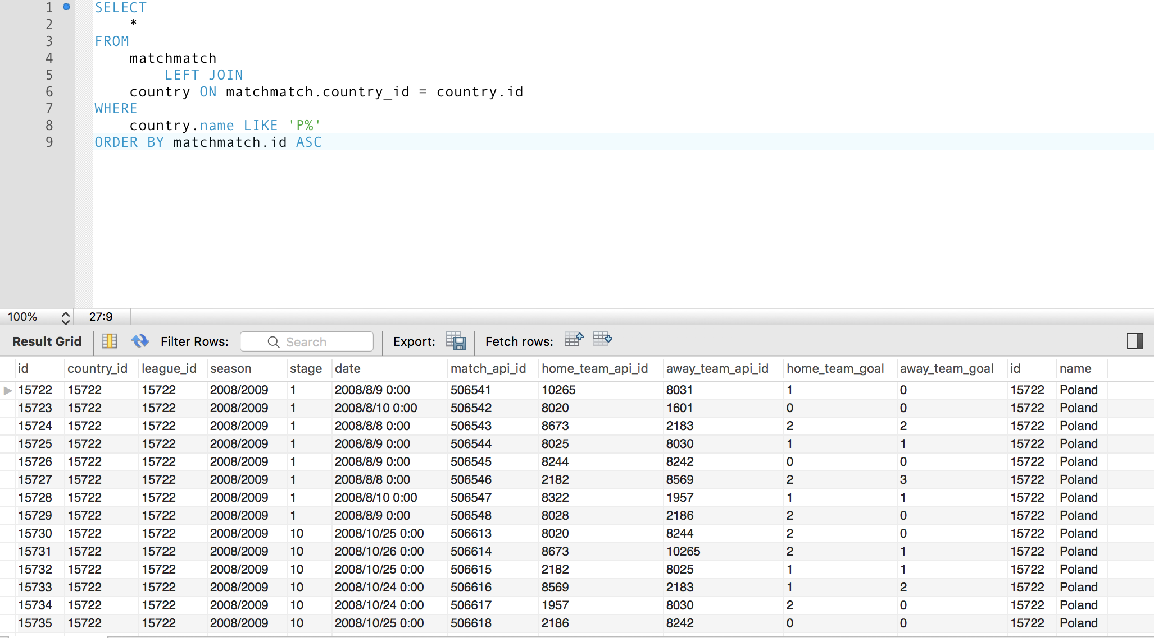

Use Case 2:

When the stage= 10, season at 2008/2009, we ranked it.

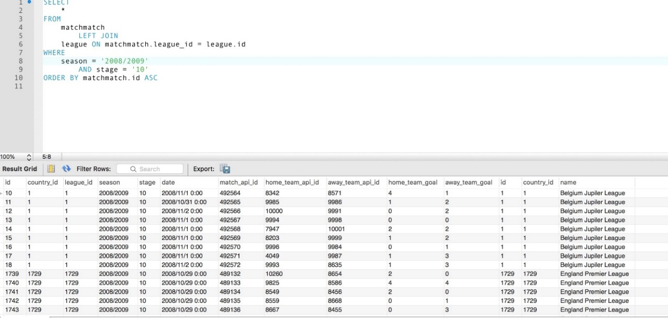

Use Case 3

We calculated the count of coach every country.

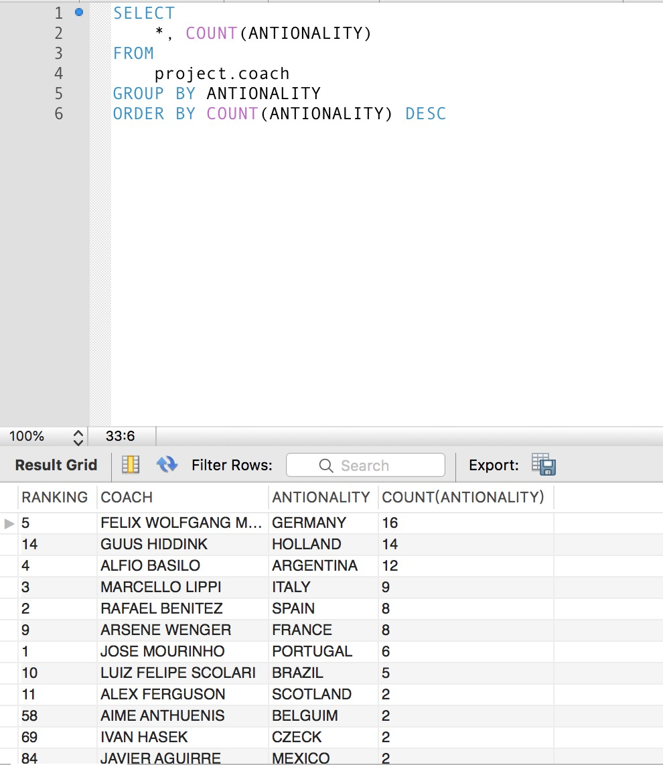

We use tweepy to get the data from the twitter API

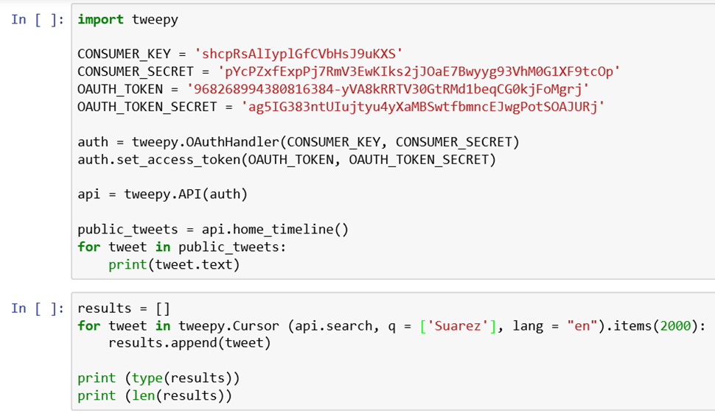

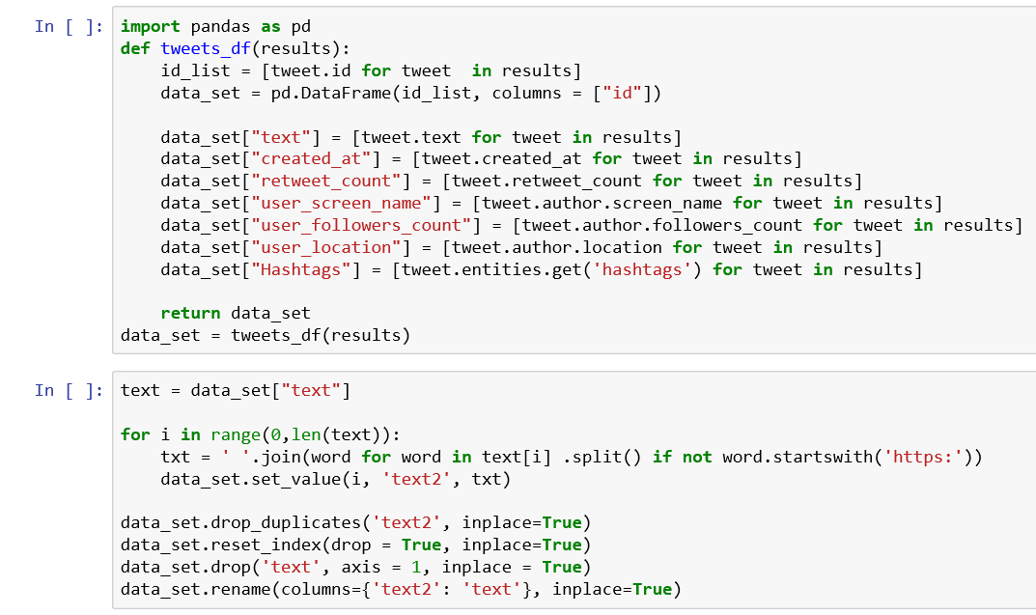

By analysis the data from twitter, we get the tag for the team and player, we get the count for the hashtag

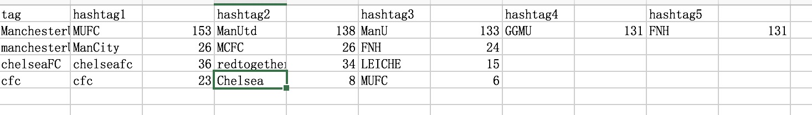

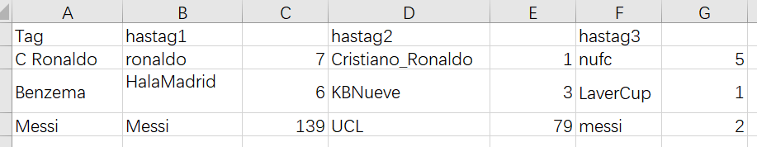

**Conclusion**

In this project, we using Mysql and python to get and analysis the date from the football matches. And also get the popularity of the team and player form twitter API. It is benefit for football fans to get the data about their team and player exactly.